Q1) Creating Microservices for account and loan

AccountController.java

package com.cognizant.account.controller;  
  
import org.springframework.web.bind.annotation.\*;  
  
import java.util.Map;  
  
@RestController  
@RequestMapping("/accounts")  
public class AccountController {  
  
 @GetMapping("/{number}")  
 public Map<String, Object> getAccountDetails(@PathVariable String number) {  
  
 return Map.*of*(  
 "number", number,  
 "type", "savings",  
 "balance", 234343  
 );  
 }  
}

Output

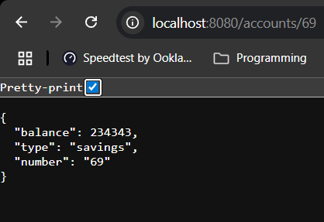

LoanController.java

package com.cognizant.loan.controller;  
  
import org.springframework.web.bind.annotation.\*;  
  
import java.util.Map;  
  
@RestController  
@RequestMapping("/loans")  
public class LoanController {  
  
 @GetMapping("/{number}")  
 public Map<String, Object> getLoanDetails(@PathVariable String number) {  
 return Map.*of*(  
 "number", number,  
 "type", "car",  
 "loan", 400000,  
 "emi", 3258,  
 "tenure", 18  
 );  
 }  
}

Output

